# Research Proposal

Title of research proposal

Principal Investigator:

Institute of Principal Investigator:

Address:

Phone:

E-mail:

Webpage:

Date:

## ABSTRACT

Summarize very briefly the purpose of the envisaged proposal; highlight the innovative and new aspects and especially the relevance and the contribution to be made to the phospholipid research area. Only this first page is available for the abstract.

Please do not exceed the page limit of **14 pages** for a research proposal – including this first page, but excluding references and appendix (CV).

Please indicate the name of the PI and the corresponding institute in the footer.

Please delete all text marked in yellow in your proposal prior submission.

## INTRODUCTION

Introduce the project.

**Subheading**

[…]

## STATE-OF-THE-ART and OWN RESEARCH

Describe briefly the state-of-the-art and also your own previos work related to the project by reviewing the latest and most relevant publications and achievements from both yourself and direct competitors working in the same field.

Please use a maximum of **three page** for the Introduction/State-of-the-art/Own research.

## AIM OF THE PROJECT

Describe which aspect of research on phospholipids is addressed and how it marks an achievement/improvement from existing research. The specific properties of phospholipids or technologies used need to be compared with proper controls (*e.g.* comparison of phospholipids with each other/other excipients with similar properties/competing technologies) to underscore the uniqueness of the envisaged findings.

**Subheading 1**

You can use tables as shown in “Table 1”. You can also use graphs or images. Captions should be in Arial, bold, 9pt.

- For images, be sure to have a good resolution.

- Please note that the words “Figure” or “Table” should be spelled out.

- Arrange the tables and figures so that they are centered on the page.

### Table 1. Captions should be in Arial, bold, 9pt.

|  |  |  |
| --- | --- | --- |
| **Headline; Arial, bold, 10pt** | **Headline** | **Headline** |
| Copy; Arial, 10pt | Copy | Copy |
| Copy | Copy | Copy |

[…]

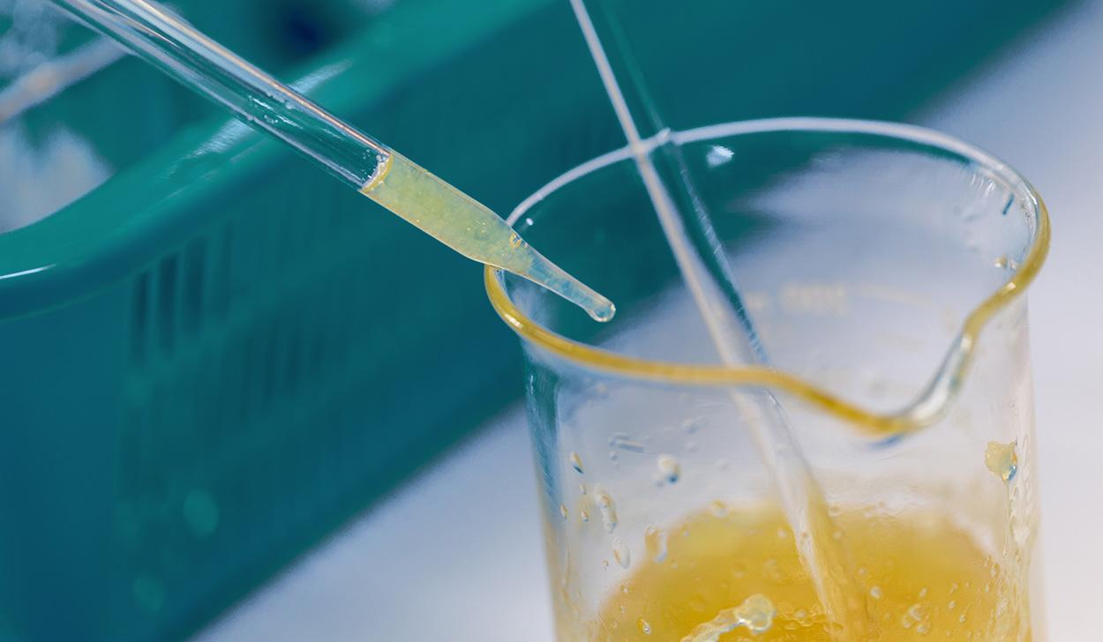

### Figure 2. Captions should be in Arial, bold, 9pt. Be sure to have a good resolution of the image.

[…]

**Subheading 2**

[…]

**Subheading 3**

[…]

## MATERIALS AND METHODS

**Drug substances**

Explain briefly the reason for selection and relevant physico-chemical properties.

**Phospholipids**

Explain briefly the selection of the lipids and the source.

**Other excipients and chemicals**

Explain these compounds only when they are very special and essential for the project.

**Preparation of (phospholipid-containing) formulations**

Equipment, batch size, solvents, drying, storage etc.

**Physico-chemical characterization of phospholipid-containing formulations**

Which analytical methods will be used?

Chemical (*e.g.* HPLC, GC), physical (*e.g.* DSC, PCS, XRPD, Raman), pharmaceutical   
(*e.g.* dissolution testing; solubility testing), other methods (*e.g.* microbiological); describe briefly the methods and measurement conditions. Mention potential collaborative partners.

***In vitro* testing**

If applicable, describe briefly the methods. Please note that the corresponding positive and negative controls of the respective experiments are also listed.

***Ex vivo* testing**

If applicable, describe briefly the methods, including bioanalytics. Please note that the corresponding positive and negative controls of the respective experiments are also listed.

***In vivo* testing**

If applicable, describe briefly the methods, including bioanalytics. Please note that the corresponding positive and negative controls of the respective experiments are also listed.

## WORK PLAN

Describe, in general terms, the step-by-step work packages (WP) which you intend to use to achieve the defined aims of the project. Only include details when this is necessary to increase the understanding of the structure and content of the particular work package. Please also include a risk analysis to assess what setbacks may occur and how they will be dealt with.

**Work package 1 (WP1)**

[…]

**Work package 2 (WP2)**

[…]

**Work package 3 (WP3)**

[…]

## RISK ASSESSMENT

Please provide a brief risk analysis of your individual work packages; What can go wrong? What will be the next steps in case of failure? What are the alternatives?

## TIMELINES

Provide the timelines in a table format as provided below:

* List chronologically the work packages (WP) with the title and short description in the second column.
* List the time frame in calendar years and quarters in the first two rows.
* Label the corresponding box to mark when the work package will be performed.
* Adapt the number of columns and rows depending on the size of the project and the number of WPs. You can, of course, further subdivide each work packages into WP 1.1, WP 1.2, etc.

|  |  |  |  |  |  |  |  |  |  |  |  |  |  |
| --- | --- | --- | --- | --- | --- | --- | --- | --- | --- | --- | --- | --- | --- |
|  | | **Starting Year** | | | | **Starting Year + 1** | | | | **Starting Year + 2** | | | |
| **WP** | **Quarter** | **1** | **2** | **3** | **4** | **1** | **2** | **3** | **4** | **1** | **2** | **3** | **4** |
| **1** | **Title** Short description |  |  |  |  |  |  |  |  |  |  |  |  |
| **2** | **Title** Short description |  |  |  |  |  |  |  |  |  |  |  |  |
| **3** | **Title** Short description |  |  |  |  |  |  |  |  |  |  |  |  |
|  |  |  |  |  |  |  |  |  |  |  |  |  |  |
|  |  |  |  |  |  |  |  |  |  |  |  |  |  |
|  |  |  |  |  |  |  |  |  |  |  |  |  |  |
|  | Interim report |  |  |  |  |  |  |  |  |  |  |  |  |
|  | Final report and/or manuscript writing |  |  |  |  |  |  |  |  |  |  |  |  |

Mention here after which WP's an interim report will be issued.

For one-year projects, an interim report should be prepared after half a year.

For three- and four-year projects, interim reports should be prepared after every year.

## BUDGET

If financial support from other organisations is foreseen, indicate it in the column 'Additional funding' in the table below. The table can be extended to provide more details.

The funding sum should be related to the country specific costs for such projects. These costs need to be justified by referring to official country specific guidelines issued by, *e.g.*, the Deutsche Forschungsgemeinschaft (DFG), the Swiss National Science Foundation (SNF), The Danish National Research Foundation (SNRF), or The Dutch Research Council (NWO), and providing copies of these guidelines.

The costs may be funded completely or partially. However, additional university overhead costs and acquisition of equipment as well as technical employees are not financed.

|  |  |  |  |  |  |  |
| --- | --- | --- | --- | --- | --- | --- |
| **Item** | **Annual costs (EUR)** | **Total costs (EUR)** | Additional funds | | **Requested funds (PRC)** | |
| Annual (EUR) | Total (EUR) | **Annual (EUR)** | **Total (EUR)** |
| **SALARIES** | | | | | | |
| PhD student |  |  |  |  |  |  |
| PostDoc |  |  |  |  |  |  |
| **OPERATIONAL EXPENSES** | | | | | | |
| Running cost: chemicals, consumables |  |  |  |  |  |  |
| Animal experiments |  |  |  |  |  |  |
| Travel expenses |  |  |  |  |  |  |
| Total costs of project |  |  |  |  |  |  |

## BENEFITS FOR THE COMMUNITY

Please summarize briefly the benefit of your research to the (lipid) community.

Up to this point, there should be no more than **14 pages**.

## REFERENCES

Mention literature references in the text and in this section using Harvard Style.

Example:

[1] van Hoogevest, P., 2017. Review – An update on the use of oral phospholipid excipients. Eur. J. Pharm. Sci., 108, pp.1–12

[2] van Hoogevest, P., Wendel, A., 2014. The use of natural and synthetic phospholipids as pharmaceutical excipients. Eur. J. Lipid Sci. Technol., 116, pp.1088–1107.

In case previous publications of the Principle Investigator are necessary for the project proposal, it is appreciated when copies of these publications are provided.

## SIGNED

|  |  |
| --- | --- |
| Name of Principal Investigator | Date and place |

## APPENDIX

**CV and expertise of Principal Investigator**

Short CV of max. one page (for each PI), highlighting the experience and interest in the phospholipid R&D area. In case of collaborative partners, mention briefly their record of achievement in the area of collaboration.